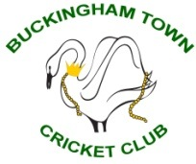

Buckingham Town Cricket Club

Code of Conduct for Junior Players

Buckingham Town Cricket Club is fully committed to safeguarding and promoting the wellbeing of all its members. The club believes that it is important that members, coaches, administrators and parents associated with the club should, at all times, show respect and understanding for the safety and welfare of others. Therefore, members are encouraged to be open at all times and to share any concerns or complaints that they may have about any aspect of the club.

As a member of Buckingham Town Cricket Club, you are expected to abide by the following junior code of conduct:

- All members must play within the rules and respect officials and their decisions

- All members must respect the rights, dignity and worth of all participants regardless of gender, ability, cultural background or religion

- Members should keep to agreed timings for training and competitions or inform their coach or team manager if they are going to be late

- Members must wear suitable kit – cricket clothing, appropriate footwear and protective equipment including batting helmets for training and match sessions, as agreed with the coach/team manager

- Members must pay any fees for training or events promptly

- Junior members are not allowed to smoke on club premises or whilst representing the club at competitions

- Junior members are not allowed to consume alcohol or drugs of any kind on the club premises or whilst representing the club.

